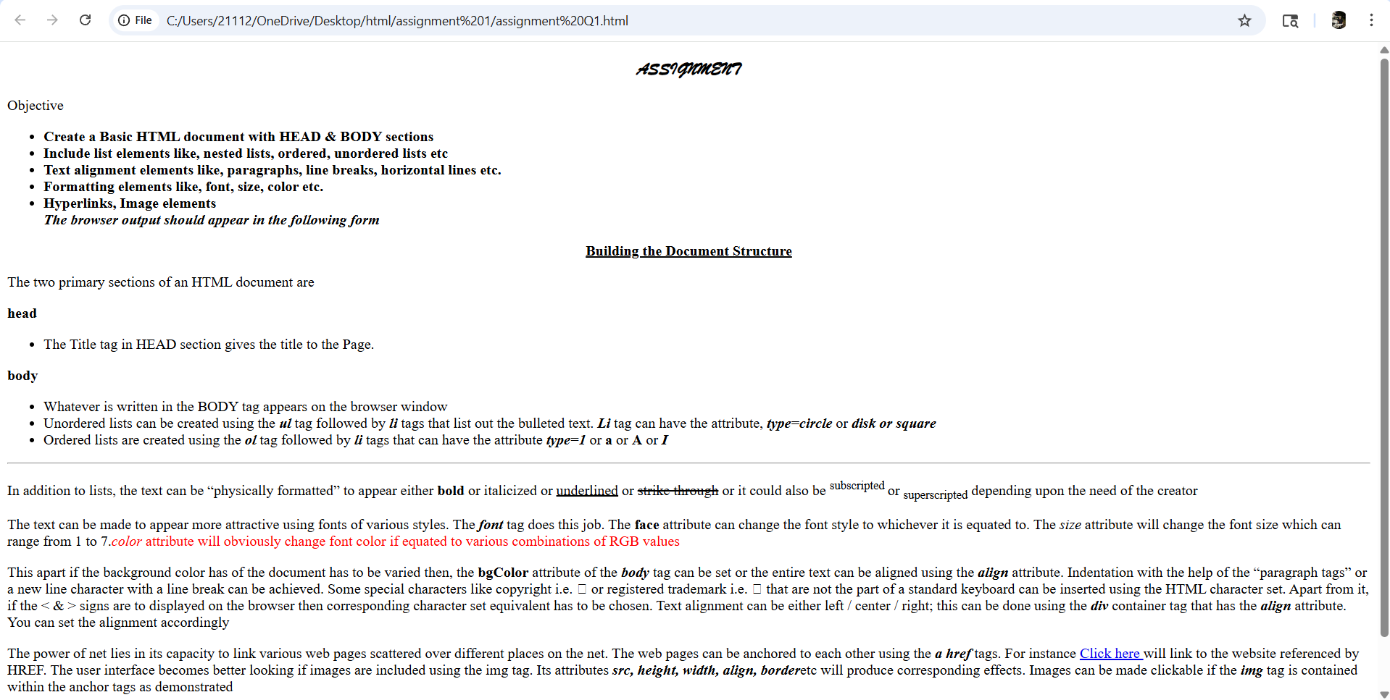

<!DOCTYPE html>
<html lang="en">
<head>
<meta charset="UTF-8">
<meta name="viewport" content="width=device-width, initial-scale=1.0">
<title>Document</title>
</head>
<body>

<center>
<h3>
<b>
<i>

<p style="font-family: Brush Script MT;">ASSIGNMENT</p>

</i>
</b>
</h3>
</center>

<h> Objective </h>

<ul>
<b>

<li> Create a Basic HTML document with HEAD & BODY sections</li>
<li> Include list elements like, nested lists, ordered, unordered lists etc</li>
<li> Text alignment elements like, paragraphs, line breaks, horizontal lines etc. </li>
<li>Formatting elements like, font, size, color etc. </li>
<li> Hyperlinks, Image elements</li>
<i> The browser output should appear in the following form</i>
</B>

</ul>

<center>
<p1>
<u>
<b>
Building the Document Structure
</u>
</B>
</p1>
</center>

<p> The two primary sections of an HTML document are</p>

<b> head</b>
<ul>
<li> The Title tag in HEAD section gives the title to the Page.</li>
</ul>
<b> body </b>
<ul>
<li> Whatever is written in the BODY tag appears on the browser window </li>
<li> Unordered lists can be created using the <b><i>ul</i></b> tag followed by <b><i>li</i></b> tags that list out the bulleted text. <b><i>Li</i></b> tag can have the attribute, <b><i>type=circle</i></b> or <b><i>disk or square</i></b> </li>
<li> Ordered lists are created using the <b><i>ol</i></b> tag followed by <b><i>li</i></b> tags that can have the attribute <b><i> type=1</i></b> or <b>a</b> or <B>A</B> or <b><i>I</i></b> </li>
</ul>
<hr>
<p>
In addition to lists, the text can be “physically formatted” to appear
either <b>bold</b> or italicized or <u>underlined</u>

or <strike>strike through</strike> or it could also be <sup>subscripted </sup>or <sub>superscripted</sub> depending
upon the need of the creator
</p>
<p>
The text can be made to appear more attractive using fonts of various styles. The <b><I>font</I></b>
tag does this job. The <b>face</b> <font>attribute can change the font style to whichever it is equated to</font>. The <i>size</i> attribute will
change the font size which can range from 1 to 7.<h style="color: red;"><i>color</i> attribute will obviously change font color if equated to
various combinations of RGB values</h>

</p>

<p>
This apart if the background color has of the document has to be varied then,
the<B> bgColor</B> attribute of the <B><I>body</I></B> tag can be set or the entire text can be aligned using the <B><I>align</I></b> attribute.
Indentation with the help of the “paragraph tags” or a new line character with a line break can be achieved. Some
special characters like copyright i.e.  or registered trademark i.e. ↓ that are not the part of a standard keyboard
can be inserted using the HTML character set. Apart from it, if the < & > signs are to displayed on the browser then
corresponding character set equivalent has to be chosen. Text alignment can be either left / center / right; this can
be done using the <B><I>div</I></B> container tag that has the <B><I>align</I></B> attribute. You can set the alignment accordingly

</p>

<P>

The power of
net lies in its capacity to link various web pages scattered over different places on the net. The web pages can be
anchored to each other using the <B><I> a href</I></B> tags. For instance <A HREF = http://www.anuda.com/index.html >Click here
</A> will link to the website referenced by HREF. The user interface becomes better looking if images are included
using the img tag. Its attributes<B><I> src, height, width, align, border</I></B>etc will produce corresponding effects. Images can
be made clickable if the <B><I> img</I></B> tag is contained within the anchor tags as demonstrated

</P>
<P>
<B>

An image is to be inserted
exactly at the bottom at the center position, should be square in shape with a border & should display a text when
the mouse moves over it. Another clickable image that will lead to a different HTML page should also be inserted at
the topmost portion of the web page, it should be wide enough to fit almost 75% of the page’s center.

</B>
</P>

</body>

